**Department of**

**Computer Engineering**

# BLG 351E Microcomputer Laboratory Experiment Report

|  |  |  |  |
| --- | --- | --- | --- |
| Experiment No |  | : 3 |  |
| Experiment Date |  | : 16.10.2017 |  |
| Group Number |  | : Monday - 8 |  |
| Group Members |  | : |  |
| **ID** |  | **Name** | **Surname** |
| 150150114 |  | EGE | APAK |
| 150140066 |  | ECEM | GÜLDÖŞÜREN |
| 150150701 |  | YUNUS | GÜNGÖR |
| Laboratory Assistant | | : Ahmet ARIŞ |  |

## 1. INTRODUCTION

In this experiment we gained more knowledge about assembly language and how to apply basic programming level concepts on assembly. Also, we have gained more experience on MSP430 educational board. And we gained more information and experience about bubble sort and basic bit wise encryption

In the first experiment we have applied given pseudocode for bit-wise encryption on MSP430 with assembly language. After that we have encrypted given example. Then we have decrypted to get first example from our encrypted example.

In the second experiment we have applied given pseudocode for bubble sort on MSP430 with assembly language. After that we have applied the algorithm to given example array.

## 2. EXPERIMENT

### 2.1. PART 1

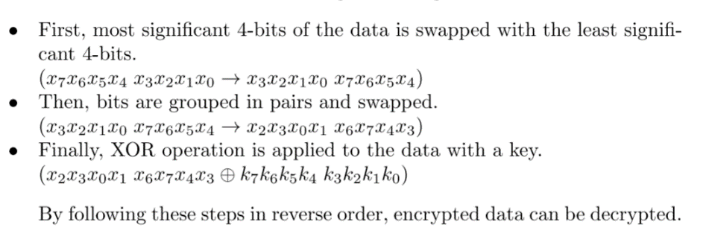In this part, we have applied given algorithm for bit wise encryption. Given algorithm swaps the most significant 4 bits with the least significant 4 bits. In our assembly code this part labeled with swap Then bits swapped in pair. This part labeled as shuffle in our code. A key used for next step. Appling XOR to swapped and shuffled bits with given key gives the final result. Appling first XOR, then shuffle and then swap decrypts given data with known key. Algorithm is given below.

After coding explained algorithm we have encrypted and decrypted given example successfully. Each step’s produced result checked by hand.

Data: 00100001

Apply key

with XOR

swap

shuffle

Example Data: 10010011

Example Key: 00010111

Data: 00110110

Data: 00111001

Decrypted

Data: 10010011

swap

shuffle

Apply key

with XOR

Data: 00111001

Data: 00110110

Data: 00100001

Figure 2.1.1: Example steps for bitwise encryption and decryption

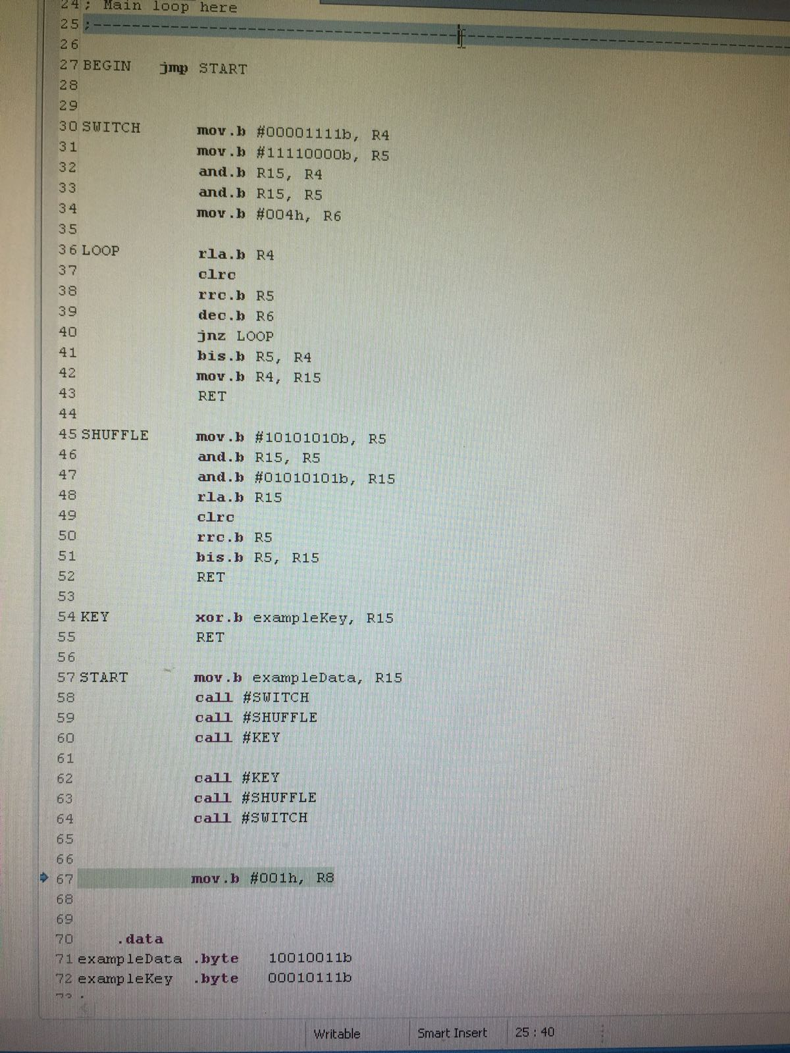

Picture 2.1.2: Code used for bitwise encryption

As seen in the code switch part where most and least significant bits swapped has a loop for shifting bits 4 times to left or to right. Most significant and least significant bits of the given data filtered with and operation and stored in R5, R4 in order. Most significant bits which is stored on R5 shifted right, and least significant bits which is stored in R4 shifted left four times. Then combined with an OR operation.

Shuffle step uses filters to get to odd numbered bits and even numbered bits. Since the aim is to swap bit pairs, we can use left shift on bits which is on odd number order and we can use right shift on bits which is on even number order. Combining those result will give us the data with switched bit pairs.

Part that labeled as key in the code uses XOR and a given key to complete encryption or start decryption.

To combine those steps R15 used as a data register. Each step starts with getting its data from R15 and ends with putting back processed data in R15. Using steps in order (switch, shuffle, key) produces encrypted data in R15. Using steps in reverse order (key, shuffle, switch) produces decrypted data.

### 2.2. PART 2

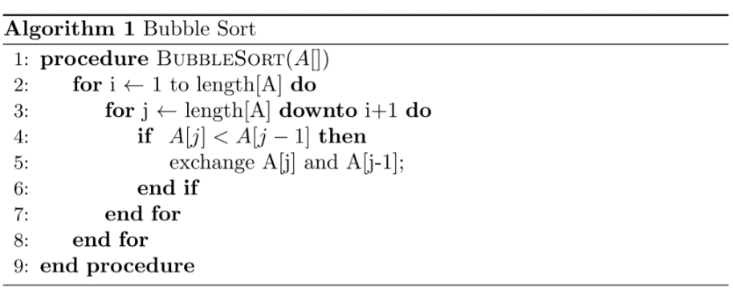 In this experiment we have applied given pseudocode for bubble sort. Creating functioning for loops in assembly was a challenging task. We have applied for using a variable to increase or decrease and comparing with a constant in each step.

Picture 2.2.1: Pseudocode for bubble sort

After we have applied for loops in assembly, we have implemented if statement and exchange part using a temporary register. Then we have realized that we can simplify the solution by using direct addresses in for loops rather than variables.

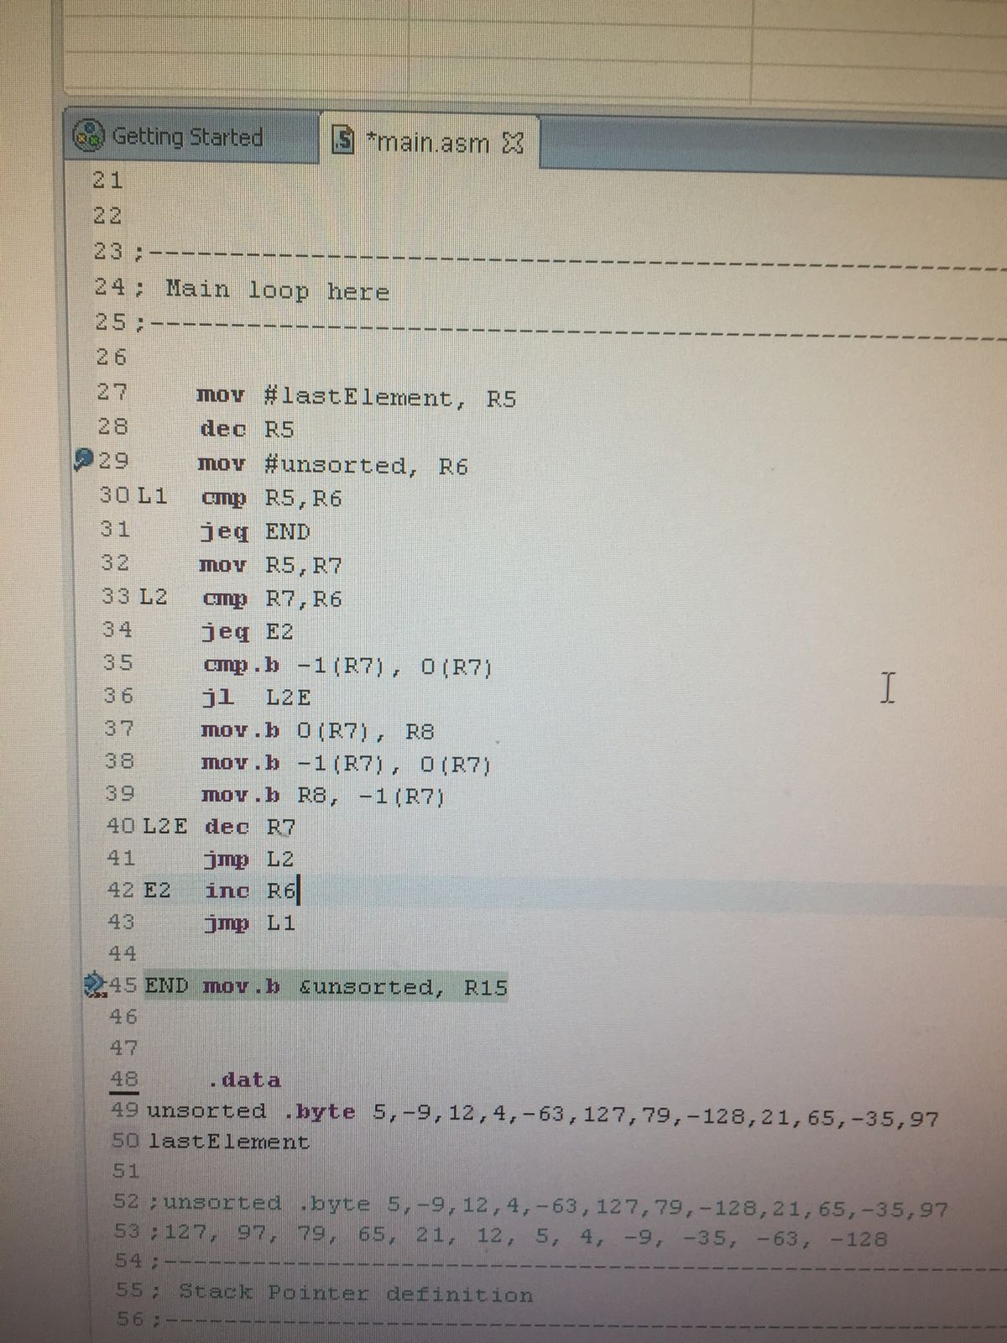

Picture 2.2.2: Assembly code for bubble sort

In the code, label L1 represents first loop, and L2 represents second loop. R5 used as the last address of the array. R6 and R7 used as variables in loops. And R8 used as temporary register in swap operation. After the implementation, given array sorted by decreasing order.

## 3. CONCLUSION

In this experiment we learned to implement loops and implement bit operations such as filtering and shifting. Also gained experience on assembly language and on MSP430 microcontroller. Also we have learned to how to debug complicated structures like loops in assembly language. Debugging and checking work flow on loop inside loop was a great challenge. Using breakpoints and memory browser helped us in debugging. We also used memory browser for checking results for part 2.